Go to nftrl.org and login. After logging in, click on your name in the top left corner...
(If you have forgotten your password, please click forgot password and the system will send you an email with a new one to use.)

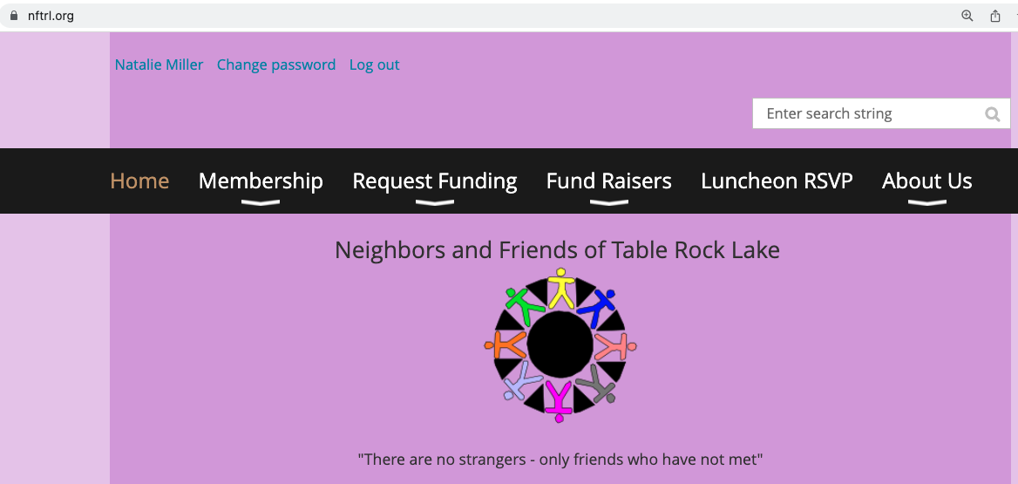

Click on Renew to 01 June 2024

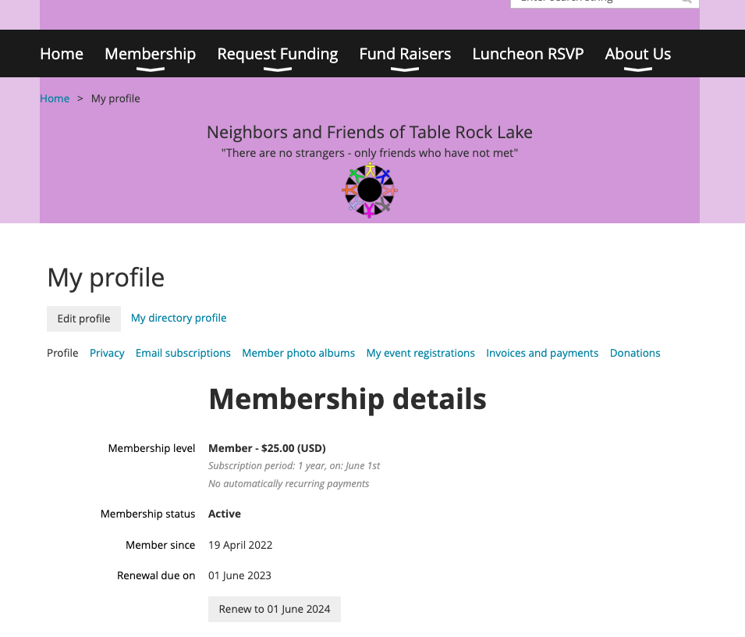

If nothing has changed, i.e. address, phone, etc., in your life, click on ‘Update and Next’...
If something has changed, scroll down on the page and you have the ability to make updates, then click ‘Update and Next’

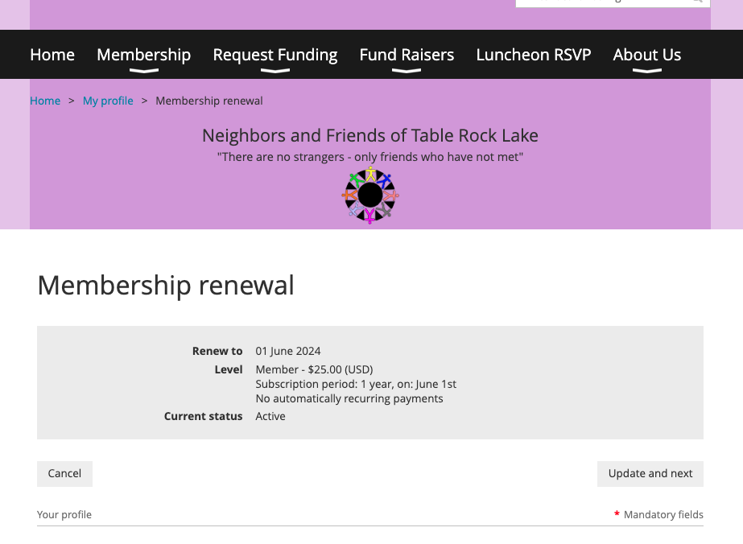

Pick to Pay Online or Invoice Me (pay by check either by mail or in person at a luncheon)
***online is the easiest, it is secure, and you will be ready for the next year without any further effort***
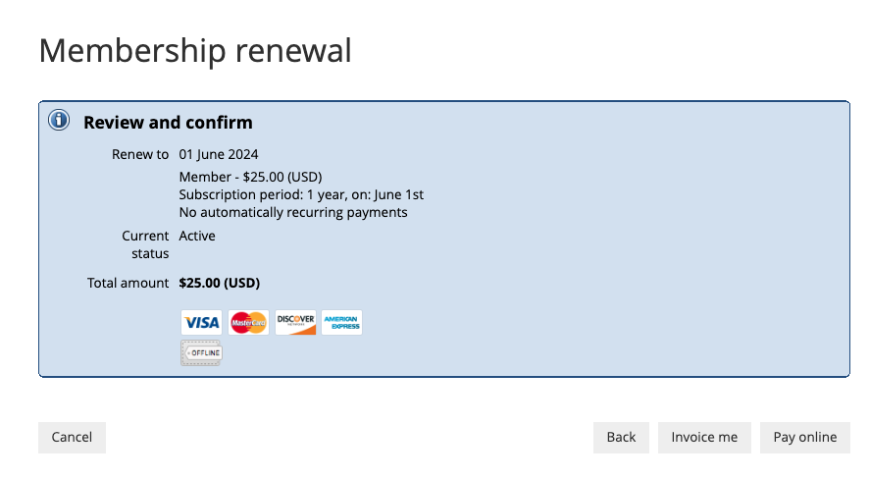

If paying online, please input your credit card info and click ‘Pay $25.00 (USD)’

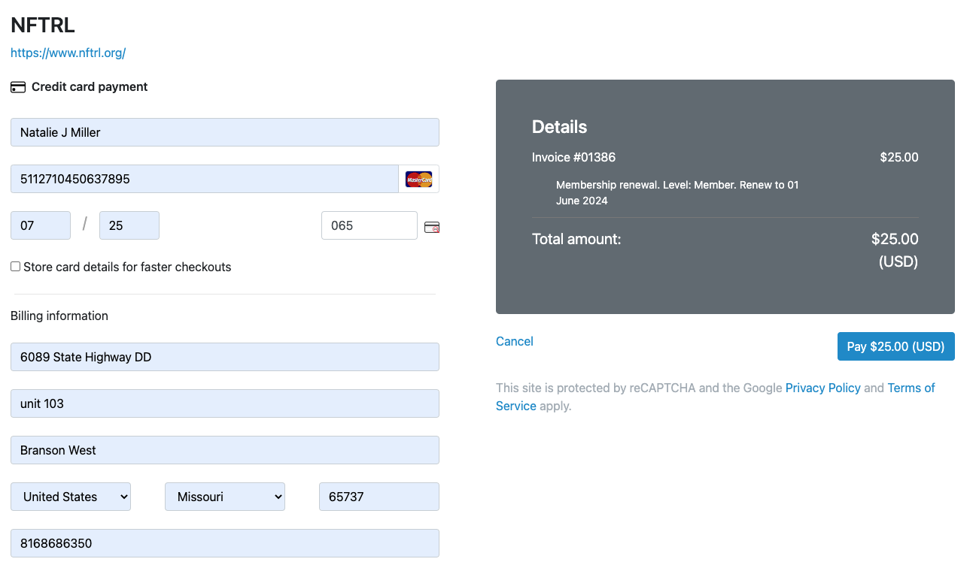
Card and billing info

There will be a ‘processing screen’... then you will receive the below... you are DONE! Thanks for being a member again in 2023-2024... we look forward to another great year!

